Toxic Gas Monitoring Circuit

Prepared for: Mr. Coglianese

Prepared by: Jared Dyreson

Due Date: 21 May 2015

Period 2

Table of Contents

1. Problem description (Page 3)
2. Truth table with variable description (Page 4)
3. Karnaugh map with unsimplified minterm expression ( Page 5)
4. Boolean Algebra simplification of unsimplified minterm expression from the truth table (Page 6)
5. Logic Diagram using AND-OR Circuit (Page 7)
6. Logic Diagram using simplified NAND implementation (Page 7)
7. Conclusion (Page 8)

Problem Description

My boss has assigned me the task of designing a circuit to monitor the concentration levels of arsenic, zinc and dihydrogen monoxide in a given solution. The solution in the tank is safe as long as the concentration levels of these three remain in specific ranges. My circuit sounds the alarm when the concentration levels are not in the specific. The alarm only sounds when:

* The amount of arsenic is out of range and the amount of dihydrogen monoxide is out of range.
* The amount of arsenic and zinc are out of range.
* The amount of all three chemical compounds are out of range.

Truth Table with variable description

|  |  |  |  |
| --- | --- | --- | --- |
| A | B | C | Alarm |
| 0 | 0 | 0 | 0 |
| 0 | 0 | 1 | 0 |
| 0 | 1 | 0 | 0 |
| 0 | 1 | 1 | 0 |
| 1 | 0 | 0 | 0 |
| 1 | 0 | 1 | 1 |
| 1 | 1 | 0 | 1 |
| 1 | 1 | 1 | 1 |

Truth Table Legend

A- Arsenic

B- Zinc

C- Dihydrogen Monoxide

0- No power, not on

1- Power, on

Unsimplified minterm expression- A $\overline{B}$ C + AB $\overline{C}$ + ABC

Karnaugh Map unsimplified minterm

|  |  |  |  |  |  |
| --- | --- | --- | --- | --- | --- |
|  |  | $$\overline{BC}$$ | $\overline{B}$ C | BC | B $\overline{C}$ |
|  |  | 00 | 01 | 11 | 10 |
| $$\overline{A}$$ | 0 | 0 | 0 | 0 | 0 |
| A | 1 | 0 | 1 | 1 | 1 |

A $\overline{B}$ C + ABC + AB $\overline{C}$

The simplified expression: AC + AB

Boolean Algebra Simplification

A $\overline{B}$ C + ABC + AB $\overline{C}$

A $\overline{B}$ C + ABC - Absorption Law

ABC + AC - Absorption Law

AB + AC – Redundance Law

The final answer is: AB + AC

Logic Diagram using AND-OR Gates

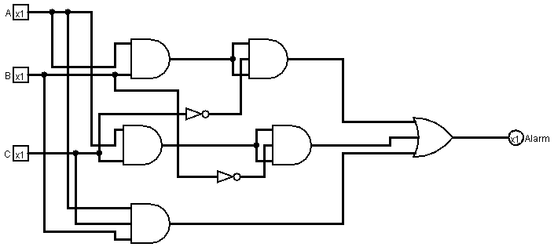

Logic Diagram using NAND Gates

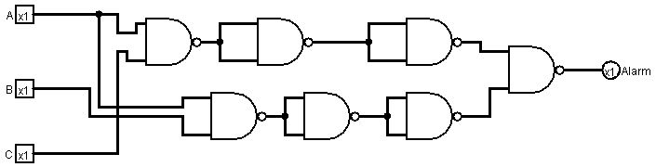

Conclusion

The nand gate circuit is the best to use for a couple of reasons. The nand circuit only uses on type of logic gate and will be easier for someone to wire because of that reason. Reason number two is that the nand gate circuit has fewer gates than the AND-OR circuit depicted on the same page.